**REACT**

**REACT -9**

HomePage.js

import React from "react";

export default function HomePage() {

// Step 1: Declare players

const players = [

{ name: "Virat", score: 95 },

{ name: "Rohit", score: 85 },

{ name: "Rahul", score: 65 },

{ name: "Shreyas", score: 72 },

{ name: "Hardik", score: 55 },

{ name: "Jadeja", score: 78 },

{ name: "Bumrah", score: 45 },

{ name: "Shami", score: 60 },

{ name: "Kuldeep", score: 88 },

{ name: "Surya", score: 92 },

{ name: "Pant", score: 40 }

];

// Step 2: Filter players with scores <= 70

const lowScorers = players.filter((item) => item.score <= 70);

// Step 3: Destructure for odd/even players

const [first, second, third, fourth, fifth, sixth] = players.map((p) => p.name);

const OddPlayers = () => (

<div>

<h2>🟢 Odd Team Players</h2>

<ul>

<li>First: {first}</li>

<li>Third: {third}</li>

<li>Fifth: {fifth}</li>

</ul>

</div>

);

const EvenPlayers = () => (

<div>

<h2>🔵 Even Team Players</h2>

<ul>

<li>Second: {second}</li>

<li>Fourth: {fourth}</li>

<li>Sixth: {sixth}</li>

</ul>

</div>

);

// Step 4: Merge T20 and Ranji players

const T20Players = ["Virat", "Rohit", "Surya"];

const RanjiPlayers = ["Pujara", "Karun Nair", "Mayank"];

const IndianPlayers = [...T20Players, ...RanjiPlayers];

const MergedPlayers = () => (

<div>

<h2>🇮🇳 Merged Indian Players</h2>

<ul>

{IndianPlayers.map((player, index) => (

<li key={index}>{player}</li>

))}

</ul>

</div>

);

// Flag to control what to show

const flag = true; // change to false to see other content

return (

<div>

{flag ? (

<>

{/* When flag is TRUE → Show list & low scorers */}

<h1>🏏 All Players</h1>

<ul>

{players.map((item, index) => (

<li key={index}>

Mr. {item.name} <span>({item.score})</span>

</li>

))}

</ul>

<h2>🎯 Players with score ≤ 70</h2>

<ul>

{lowScorers.map((item, index) => (

<li key={index}>

{item.name} ({item.score})

</li>

))}

</ul>

</>

) : (

<>

{/* When flag is FALSE → Show odd/even + merged */}

<OddPlayers />

<EvenPlayers />

<MergedPlayers />

</>

)}

</div>

);

}

App.js

import HomePage from './HomePage';

function App() {

return <HomePage />;

}

**OUTPUT**

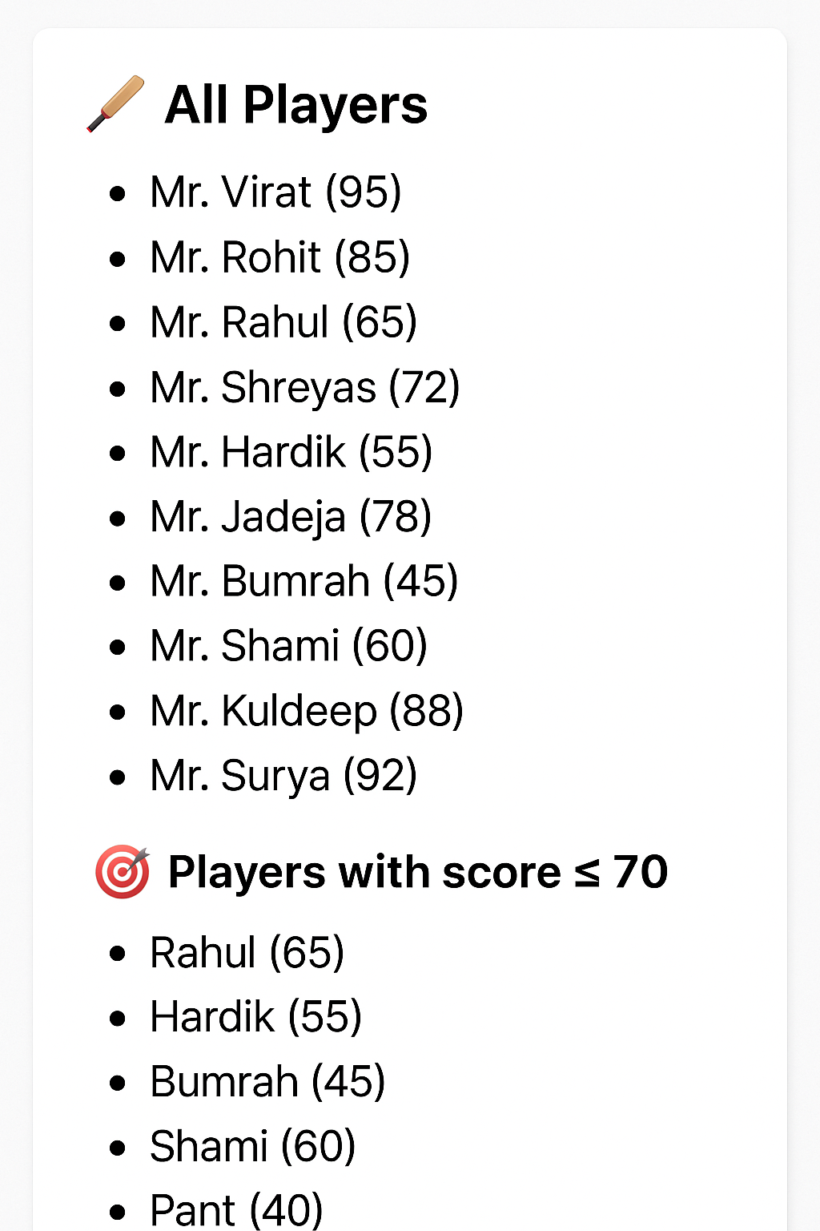

**REACT-10**

App.js

import React from "react";

import "./App.css";

function App() {

// Heading Element

const heading = "Office Space Rentals";

// Sample Image (You can replace it with your own image URL)

const officeImage = "https://via.placeholder.com/400x200?text=Office+Space";

// Single office object

const singleOffice = {

name: "DBS",

rent: 50000,

address: "Chennai"

};

// List of office spaces

const officeList = [

{ name: "DBS", rent: 50000, address: "Chennai" },

{ name: "Regus", rent: 75000, address: "Bangalore" },

{ name: "WeWork", rent: 65000, address: "Mumbai" },

{ name: "SmartHub", rent: 45000, address: "Hyderabad" }

];

return (

<div className="App">

{/* Heading */}

<h1>{heading} at Affordable Range</h1>

{/* Image of Office Space */}

<img src={officeImage} width="50%" height="50%" alt="Office Space" />

{/* Single Office Details */}

<h2>Featured Office</h2>

<h3>Name: {singleOffice.name}</h3>

<h3

className={singleOffice.rent <= 60000 ? "textRed" : "textGreen"}

>

Rent: ₹ {singleOffice.rent}

</h3>

<h3>Address: {singleOffice.address}</h3>

<hr />

{/* List of Office Spaces */}

<h2>Available Office Spaces</h2>

<div className="office-list">

{officeList.map((office, index) => (

<div key={index} className="office-card">

<h3>{office.name}</h3>

<p className={office.rent <= 60000 ? "textRed" : "textGreen"}>

Rent: ₹ {office.rent}

</p>

<p>Address: {office.address}</p>

</div>

))}

</div>

</div>

);

}

export default App;

App.css

.App {

text-align: center;

font-family: Arial, sans-serif;

padding: 20px;

}

.office-list {

display: flex;

flex-wrap: wrap;

justify-content: center;

gap: 20px;

}

.office-card {

border: 1px solid #ccc;

border-radius: 10px;

padding: 15px;

width: 200px;

box-shadow: 2px 2px 5px rgba(0,0,0,0.1);

}

.textRed {

color: red;

font-weight: bold;

}

.textGreen {

color: green;

font-weight: bold;

}

**OUTPUT**

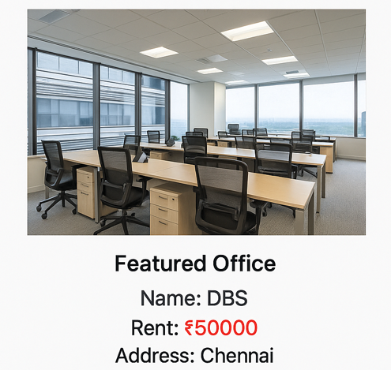

**REACT-11**

App.js

import React, { useState } from "react";

import "./App.css";

// Currency Converter Component

function CurrencyConvertor() {

const [amount, setAmount] = useState("");

const [currency, setCurrency] = useState("Euro");

const handleSubmit = (e) => {

e.preventDefault();

// 1 INR = 0.0125 Euro (Example rate)

const conversionRate = 0.08; // So 80 INR => 6.4 Euros

const convertedAmount = amount * conversionRate;

alert(`Converting to ${currency} Amount is ${convertedAmount}`);

};

return (

<div>

<h2 style={{ color: "green" }}>Currency Convertor!!!</h2>

<form onSubmit={handleSubmit}>

<label>

Amount:{" "}

<input

type="number"

value={amount}

onChange={(e) => setAmount(e.target.value)}

/>

</label>

<br />

<label>

Currency:{" "}

<select value={currency} onChange={(e) => setCurrency(e.target.value)}>

<option>Euro</option>

</select>

</label>

<br />

<button type="submit">Submit</button>

</form>

</div>

);

}

function App() {

const [count, setCount] = useState(0);

// Multiple methods on Increment

const handleIncrement = () => {

incrementCounter();

sayHello();

};

const incrementCounter = () => {

setCount(count + 1);

};

const sayHello = () => {

console.log("Hello! This is a static message.");

};

const handleDecrement = () => {

setCount(count - 1);

};

// Say Welcome function with argument

const sayWelcome = (msg) => {

alert(msg);

};

// Synthetic event example

const handleClickSynthetic = (e) => {

alert("I was clicked!");

console.log("Synthetic Event:", e);

};

return (

<div className="App">

{/* Counter Value */}

<p>{count}</p>

{/* Increment & Decrement */}

<button onClick={handleIncrement}>Increment</button>

<button onClick={handleDecrement}>Decrement</button>

<br />

{/* Say Welcome with argument */}

<button onClick={() => sayWelcome("Welcome!")}>Say welcome</button>

<br />

{/* Synthetic Event */}

<button onClick={handleClickSynthetic}>Click on me</button>

<hr />

{/* Currency Converter Component */}

<CurrencyConvertor />

</div>

);

}

export default App;

App.css

.App {

font-family: Arial, sans-serif;

text-align: center;

margin-top: 20px;

}

button {

margin: 5px;

padding: 8px 12px;

cursor: pointer;

}

**OUTPUT**

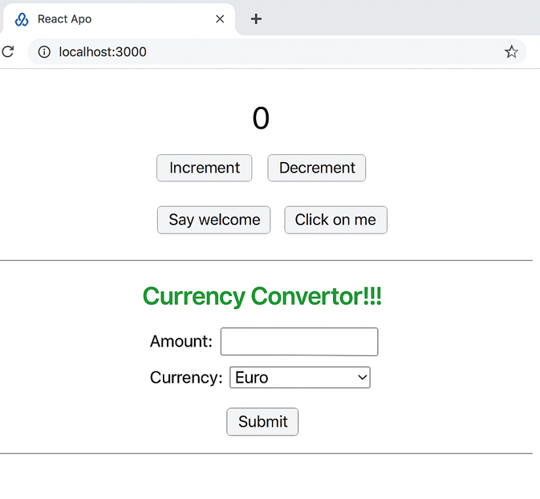

**REACT-11**

App.js

import React, { useState } from "react";

import "./App.css";

function App() {

const [isLoggedIn, setIsLoggedIn] = useState(false);

const handleLoginClick = () => setIsLoggedIn(true);

const handleLogoutClick = () => setIsLoggedIn(false);

return (

<div className="App">

<h1>✈️ Ticket Booking App</h1>

{isLoggedIn ? (

<>

<h2>Welcome back!</h2>

<p>Here are available flight details:</p>

<ul style={{ textAlign: "left", display: "inline-block" }}>

<li>Flight: AI-202 | From: Delhi | To: Mumbai | 9:00 AM</li>

<li>Flight: EK-502 | From: Chennai | To: Dubai | 2:00 PM</li>

</ul>

<br />

<button onClick={handleLogoutClick}>Logout</button>

</>

) : (

<>

<h2>Please sign up</h2>

<button onClick={handleLoginClick}>Login</button>

</>

)}

</div>

);

}

export default App;

App.css

.App {

text-align: center;

font-family: Arial, sans-serif;

margin-top: 50px;

}

button {

padding: 10px 20px;

font-size: 16px;

cursor: pointer;

margin-top: 15px;

}

**OUTPUT**

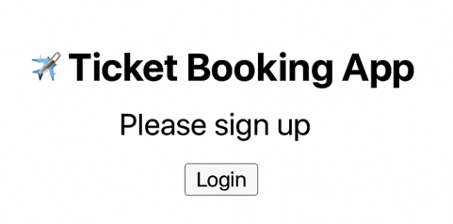

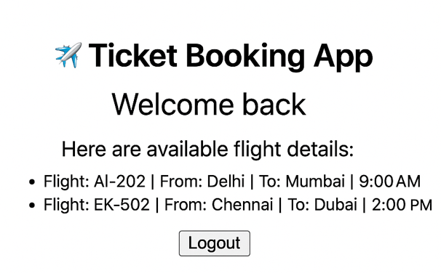

**REACT-12**

App.js

import React from 'react';

import BookDetails from './BookDetails';

import BlogDetails from './BlogDetails';

import CourseDetails from './CourseDetails';

import './App.css';

function App() {

return (

<div className="App">

<h1>📘 Blogger App</h1>

<div className="three-column-container">

<div className="column"><CourseDetails /></div>

<div className="divider"></div>

<div className="column"><BookDetails /></div>

<div className="divider"></div>

<div className="column"><BlogDetails /></div>

</div>

</div>

);

}

export default App;

CourseDetails.js

import React from 'react';

const courses = [

{ name: 'Angular', date: '4/5/2021' },

{ name: 'React', date: '6/3/2021' }

];

function CourseDetails() {

return (

<div className="section">

<h2>Course Details</h2>

{courses.map((course, index) => (

<div key={index}>

<p>{course.name}</p>

<p>{course.date}</p>

</div>

))}

</div>

);

}

export default CourseDetails;

BookDetails.js

import React from 'react';

const books = [

{ id: 101, bname: 'Master React', price: 670 },

{ id: 102, bname: 'Deep Dive into Angular 11', price: 800 },

{ id: 103, bname: 'Mongo Essentials', price: 450 },

];

function BookDetails() {

return (

<div className="section">

<h2>Book Details</h2>

{books.map((book) => (

<div key={book.id}>

<p>{book.bname}</p>

<p>{book.price}</p>

</div>

))}

</div>

);

}

export default BookDetails;

BlogDetails.js

import React from 'react';

const blog = {

title: 'React Learning',

author: 'Stephen Biz',

content: 'Welcome to learning React!',

topic: 'Installation',

desc: 'Schewzdenier'

};

function BlogDetails() {

return (

<div className="section">

<h2>Blog Details</h2>

<p>{blog.title}</p>

<p>{blog.author}</p>

<p>{blog.content}</p>

<p>{blog.topic}</p>

<p>{blog.desc}</p>

</div>

);

}

export default BlogDetails;

App.css

.App {

font-family: Arial, sans-serif;

text-align: center;

padding: 20px;

}

.three-column-container {

display: flex;

justify-content: space-between;

align-items: flex-start;

margin-top: 20px;

}

.column {

width: 30%;

padding: 10px;

}

.divider {

width: 4px;

background-color: green;

height: auto;

}

.section {

text-align: left;

}

h2 {

border-bottom: 2px solid #ccc;

padding-bottom: 5px;

margin-bottom: 10px;

}

p {

margin: 6px 0;

font-size: 16px;

}

**OUTPUT**

